Choose the letter of the correct answer. For all questions, NOTA means “none of the above”.

1. What does 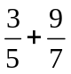= ?
A.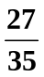 B. 1 C. 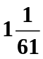 D. 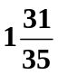 E. NOTA

2. What is 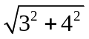?
A. 4 B. 5 C. 47 D. 25 E. NOTA

3. If x + 5 = 27, find x
A. -32 B. -22 C. 22 D. 32 E. NOTA

4. Find 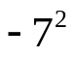
A. -49 B. -14 C. 14 D. 49 E. NOTA

5. What is 15% of 25?
A. 2.75 B. 10 C. 15 D. 21.25 E. NOTA

6. What is the numerical coefficient of 3xy?
A. 1 B. 2 C. 3 D. 4 E . NOTA

7. Evaluate to simplest terms 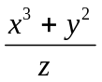 for x = 2, y = 5, z = 12
A. – B. 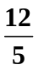 C.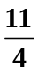 D.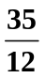 E . NOTA

8. Which term comes next in the sequence 1, 2, 4, 7, 11?
A. 5 B. 13 C. 16 D. 24 E. NOTA

9. What is the Additive Inverse of –(– 25)?
A. –25 B. –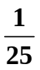 C. D. 25 E. NOTA

10. Fill in the missing symbol to the statement: -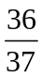 ____ -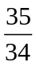
A. < B. > C. D. E. NOTA

11. Simplify 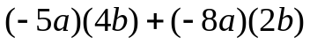
A. 36ab B. 2ab C. –2ab D. –36ab E. NOTA

12. Solve for x, 2x = -24
A. 12 B. 6 C. –6 D. –12 E. NOTA

13. You have scores of 88, 95, and 100 on your quizzes. What do you need to get on your next quiz to average exactly 94?
A. 90 B. 92.5833 C. 93 D. 94 E. NOTA

14. Simplify 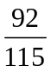
A.  B.  C. D. E. NOTA

15. Express 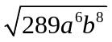 in simplest terms. Assume a and b are positive numbers.
A. 17ab B. 816ab C. 2ab D. 0 E. NOTA

16. Which one of the following statements is true?
A. 1 is an integer
B. x + 0 = x is the reflexive property
C. The area of a triangle is defined as base times height
D. None are true
E. NOTA

17. Simplify 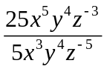
A. 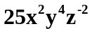 B. 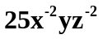 C. 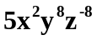 D. 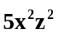 E. NOTA

18. What is two-thirds of 36?
A. 12 B. 24 C. 36 D. 54 E. NOTA

19. Solve for a: 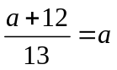
A. 12 B. 0 C. 1 D. 24 E. NOTA

20. Solve the systems of equations for (x,y):
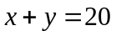
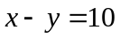
A. (5,10) B. (15,20) C. (-15,-5) D. (15,5) E. NOTA

21. Solve the systems of equations for (x,y):
16x + 12y = 36
64x = 144 – 48y

A. (0,3) B. (1,12) C. ℜ D. ∅ E. NOTA

22. Naruto ran out of weapons. Shurikens cost 3 dollars each and knives cost 4 dollars each. If Naruto started with 36 dollars and decides to buy 8 shurikens, how many knives can Naruto buy?
A. 0 B. 1 C. 2 D. 3 E. NOTA

23. What is the distance on the coordinate plane from (0,0) to (3,4)?
A. 2 B. 3 C. 4 D. 5 E . NOTA

24. If a frog can jump 6 meters vertically and Naruto can jump of that height, how high vertically can Naruto jump?
A. 4 meters B. 8 meters C. 16 meters D. 32 meters E. NOTA

25. Naruto is flat tired out. He decides to go to bed to regain stamina. If for every 3 hours of rest Naruto regains 4 stamina, and right now he has 0 stamina, how many hours of rest should Naruto get to have 36 stamina?
A. 9 B. 27 C. 36 D. 48 E. NOTA

26. Naruto now has 36 stamina, and he decides to change half of it into Chakra. If 1 stamina equals 3 Chakra, how much Chakra does Naruto now have?
A. 1 B. 9 C. 54 D. 108 E. NOTA

27. If for every dollar Naruto spends, 50 cents will be donated to hurricane relief, and for every dollar donated to hurricane relief, only 60 cents are actually used for hurricane relief, how many dollars should Naruto spend to ensure 30 dollars are actually used for hurricane relief?
A. 10 B. 80 C. 100 D. 300 E. NOTA

28. Naruto has decided to journey to another village. If going by foot, Naruto will travel at a rate of 10 mph and there are 80 miles to travel. If going by boat he will travel at 5 mph and there are 45 miles to travel. If Naruto trasvels by wagon he will travel at 2 mph to cover the 20 miles. Which method should Naruto travel by to reach the other village fastest?
A. wagon B. foot C. boat D. unable to tell E. NOTA

29. If Naruto must pay 300 dollars to learn a top-secret skill, and his job currently pays 20 dollars an hour, how many hours must Naruto work to pay for the skill, if he has 100 dollars right now?
A. 40 B. 30 C. 20 D. 10 E. NOTA

30. What is 1+1?
A. 0 B. 1 C. 2 D. 3.14159265 E. NOTA

Answer Key-Algebra I
1. D
2. B
3. C
4. A
5. E
6. C
7. C
8. C
9. A
10. B
11. D
12. D
13. C
14. C
15. E
16. A
17. D
18. B
19. C
20. D
21. C
22. D
23. D
24. C
25. B
26. C
27. C
28. B
29. D
30. C

